Tag: Oceanographic Research Institute

FISH POACHING AT SOUTH AFRICAN OCEANS REACHING ‘CRISIS’ PROPORTIONS!

Fishing sector researchers sound the alarm about popular fish species in South Africa’s seas being ‘poached’ to extinction, and call for general public involvement.

Posted on February 3, 2016February 3, 2016

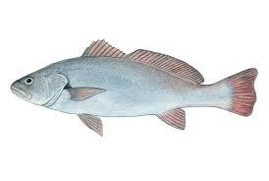By the time there are only about half-a-dozen rhinos and perhaps only three elephants left in South Africa’s wild, all due to rampant and incessant poaching; there may also be no more edible fish left in the country’s oceans, such is an apparent massive scale of poaching also of popular fish species along the country’s coastline, according to two researchers.
Professor Nadine A. Strydom and Bruce Mann’s story of an apparent desperate plight of the country’s fish species’ rapid decimation is carried in the January/February 2016 edition of Ski-Boat, a bimonthly print and digital magazine published by the South African Deep Sea Angling Association.
Prof Strydom is an associate professor in the Department of Zoology at the Nelson Mandela Metropolitan University (NMMU) in Port Elizabeth. She is described as a specialist in the ecology of and early life history of coastal fish.

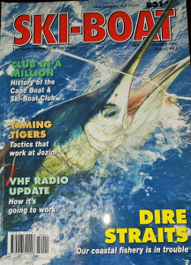

Mr Mann is a fish biologist based at the Oceanographic Research Institute in Durban. He is said to be a specialist in the stock status, biology and ecology of linefish and marine protected areas.
A collaborator and contributor in the report is Mr Edward Turner, a sportfishing journalist involved in tourism development.
According to their report, an increasingly popular question in the South Africa fishing sector is: “Where have all the fish gone?”
Their alarm bell comes in the same period as the Department of Agriculture, Forestry and Fisheries (DAFF) is in the process of finalizing the receiving of application forms and issuance of related policy documents, beginning February 1, 2016; for Fishing Rights Allocation for the 2015/16 period.
The researchers’ report also coincides with the release of the South African Maritime Safety Authority (SAMSA) Centre for Fishing’s annual fishing sector incidents report (Marine Notice No.1 of 2016) and which, summarily; paints an apparently encouraging picture in terms of gradually yet consistent reducing rates of deaths of fishermen through accidents and related in the country’s seas over the last decade or so.
Meanwhile, the researchers’ report on the dire conditions facing the country’s fish stock, describes none of it as being actually a joke as, they say; of 35 popular linefish species in a 2013 study report known as the ‘Southern African Marine Linefish Species Profiles‘ and published by the South African Association for Marine Biological Research (Oceanographic Research Institute), more than half (19) of the popular linefish had ‘collapsed’, 6 (six) were over-exploited, with only 10 perceived as ‘optimally exploited.’
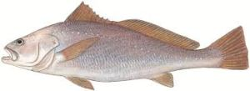
The researchers state: “Much media attention is placed on charismatic animals like elephants and rhinos and the anti-poaching messages are common on t-shirts and bumber stickers, but much less attention is given to the plight of our fish species.“Many of our coastal fish species suffer a similar plight to rhino, with rampant poaching serving the greedy few while deriving (sic) other South Africans of their natural heritage. Sadly, the media hype about rhinos seems to miss other threatened species, particularly those that are hard for people to see on a daily basis,” so says the group.

Big fish, the most productive, are gone!
Sounding a shrill alarm, the experts claim that the current favourite target for fish poachers along South Africa’s coastal waters are big-sized fish, such as a fully grown dusky kob, and the greatest tragedy is that these large fish are also incidentally, the best breeders over time. They are all almost all gone, say the researchers!
“The dusky kop is just one on a long list of fish species for which alarm bells are ringing. Populations of many popular angling fish that formed an integral part of the rock-and-surf, estuary and SkiBoat fisheries in the past 50 years are already collapsed off our coast,” they say.
Precisely, line fish said to be under severe threat in South African oceans over the last few years include the following in four categories:
- over-fished: the Silver Kob, the Squaretail Kob, and the Geelbek.
- vulnerable: the Dusky Kob, the Black musselcracker, the White-edged rock cod, the Scotsman, the Soup fin shark and the Smooth hound shark,
- endangered: the White steenbras, the Red steenbras, the Yellowbelly rockcod, and the Red stumpnose and
- critically endangered: the Seventy-four and the Dageraad
Apparently, according to the researchers in their January/February 2016 report, the only refuge for many of the fish species are Marine Protected Areas (MPAs) such as the ISimangaliso, Pondolond, Tsitsikama, Goukamma and De Hoop areas along the Indian Ocean east of the country.
However, they say; even these protected areas are only currently serving to keep pressure at bay in the immediate vicinity of the protected areas, as outside them, it is chaos.
In its 5-year strategy document for the period 2015/16-2019/20 DAFF acknowledges the problem and gives a broad outline of its planned activities in the period to counter the trend.
In the document DAFF states: “Fisheries generally is a highly contested industry, both locally and globally. It is plagued by syndicated crime, over-exploitation of high-value species, corruption and poor compliance levels.
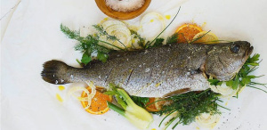
“The department, therefore, has to introduce comprehensive responses to this complex, highly technical and technologically advanced challenge by intensifying its monitoring and compliance efforts and working in close cooperation with other law enforcement
agencies.”

In their report however, Prof Strydom and Messrs. Mann and Truter, while acknowledging fully a laxity in management and enforcement of fisheries regulations as a primary factor, a lack of public awareness compounds the problem and they believe, they say, that the public should “do more than just eat fish at restaurants.”
South Africans reportedly consumed approximately 313-million tons of seafood in 2010, of which 50% was sourced within the country’s waters. Much of that seafood constituted a variety of fish species.
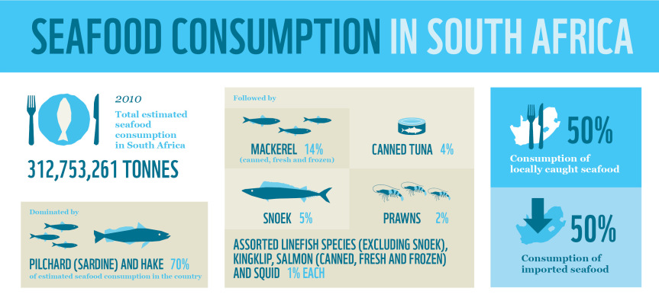Illustrative chart courtesy of WWF-SASSI. For a link to the website, click on the chart.
“The future of our fish resources in South Africa rests in the mouths of those of us who eat seafood – both anglers themselves and those who by their seafood at restaurants and the local fish shop. You are ultimately the end users of coastal fish in South Africa and you have a moral obligation to participate in conversation effort for our fish stocks,” they urge.

Tools to assist public’s direct involvement and engagement
To assist the greater public engagement sought, the researchers point to a dedicated digital platform known as the Southern African Sustainable Seafood Initiative (SASSI) and which contains loads of information to assist especially fish dealers and consumers with knowledge about the fish they trade in or consume.
For retailers, the WWF-SASSI platform provides fish traders with information that includes guidelines to procurement of linefish from dealers operating in South Africa’s oceans.
In addition, the platform reportedly supports general members of the public by, for example: enabling people to, while seated at a restaurant, SMS the name of the fish on the menu they have ordered to a dedicated mobile number that in turn returns all the critical information known about the fish species, inclusive of its state of abundance or scarcity and some such other detail.
To encourage ease of use by the public, the platform also offers an app that can be loaded to a person’s mobile phone for purposes of accessing same information and alternatively, a downloadable booklet containing loads of knowledge about the country’s fish species and their current status.
“The demise of the dusky kob in coastal waters of South Africa is no less imminent than the threat faced by the rhino, elephant, abalone and others like them. Marine biologists are calling on all South Africans to step up and help fight the cause to ensure the sustainable use of our precious coastal fish resources,” says Prof Strydom and Messrs Mann and Truter.
Fewer deaths of fishermen on SA waters
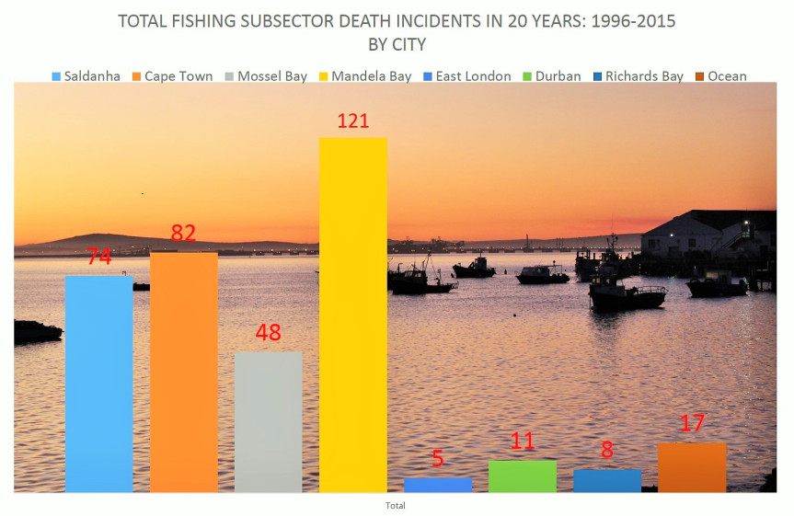
**Meanwhile, a SAMSA report of recorded incidents of death at sea for the past 20 years (1996-2015) indicates a significant decline in the number of fishermen who die at see while at work.

Compiled by SAMSA’s Centre for Fishing, the report shows that even as the number of fishermen who died while at work at sea in 2015 more than doubled from only seven (7) in 2014 to 18 in 2015, the overall death trend reflected a significant decline particularly in the last decade from 2006 to 2015.
In the period, fishermen death numbers fell from double digit figures, sometimes as high as 57 per annum in the period from 1996 to 2005, to single digits of as low seven deaths per annum in the last decade.
…………………………

